

Dissertation Proposal Form

Date of Submission:

Name | Joseph Oluwasanmi Owolabi
Student Id | 240249395
Module Code | COM73040M
Project Title: | AI-Based Detection of DDoS Attacks in IoT Smart Home Environments
Supervisor Name | Dr Soonleh Ling
Supervisor Approval | Yes
Supervisor Signature | 

Section 1: Academic
This section helps Academic staff assess the viability of your project. It also helps identify the most appropriate supervisor for your proposed research. This proposal will be referred to as a point of discussion by your supervisor in seminar sessions.

NAME: Joseph Oluwasanmi Owolabi | STUDENT NUMBER: 240249395
PROPOSED TITLE OF PROJECT: AI-Based Detection of DDoS Attacks in IoT Smart Home Environment.

BRIEFLY DESCRIBE YOUR FIELD OF STUDY:
This dissertation is situated within the broader discipline of Computer Science, with a specific focus on three interrelated subfields: Cybersecurity, Artificial Intelligence (AI), and the Internet of Things (IoT).
The convergence of these areas is critical in addressing the unique security challenges emerging from the spread of smart home technologies. IoT devices such as smart thermostats, security cameras, smart TVs, and voice assistants communicate over wireless networks and often lack robust in-built security mechanisms due to their limited processing power and storage capacity. This makes them highly vulnerable to cyber threats, particularly Distributed Denial-of-Service (DDoS) attacks, where compromised devices are used to overwhelm a target system or service with traffic, rendering it unavailable to legitimate users.
The study aims to bridge the gap between traditional intrusion detection systems and the dynamic nature of modern IoT-based environments by leveraging AI. It explores how machine learning algorithms, especially those capable of anomaly detection and behavioral analysis, can be integrated into smart home networks to identify and respond to DDoS attacks in real time.
By combining cybersecurity principles with AI techniques in the context of IoT ecosystems, the research contributes to the development of smarter, more resilient digital homes.

WHAT QUESTION DOES YOUR PROJECT SEEK TO ANSWER?

- How can artificial intelligence be applied to effectively detect and mitigate DDoS attacks targeting IoT devices in smart home environments?
The project uses an Isolation Forest algorithm to detect anomalies in MQTT traffic, simulating both normal and attack scenarios. It demonstrates how AI can flag suspicious patterns in real-time to help secure smart homes.
- What patterns in MQTT traffic indicate a DDoS attack in a smart home environment?
The project analyzes message rate, device frequency, and payload consistency. DDoS attacks are identified by unusually high traffic volumes and abnormal device behavior patterns, which are logged and used to train the detection model.
- Can a lightweight, non-intrusive AI model be integrated with existing smart home platforms like Home Assistant?
Yes. The project integrates the AI model externally via Python scripts without modifying the Home Assistant core, showing that AI-based security can run in parallel with minimal system overhead.

WHAT HYPOTHESIS ARE YOU SEEKING TO TEST?
H1: AI-based models, such as Random Forest or LSTM, can accurately detect DDoS attack patterns in IoT smart homes by analyzing network traffic data, and can outperform traditional signature-based detection methods.
H2: Simulated IoT traffic using virtual sensors and MQTT protocols can effectively replicate real-world DDoS scenarios, providing a reliable dataset for training and evaluating AI-based intrusion detection systems.

WHAT ARE THE PROBABLE PROJECT OUTCOMES?
- Real-time detection of volumetric and application-layer DDoS attacks
- Reduced false alarms using behavior-based analysis
- Scalable IDS model for smart home environments
- Contributions to the design of lightweight security models for resource-constrained IoT devices

PLEASE PROVIDE A BRIEF BIBLIOGRPAHY OF 2-4 KEY TEXTS FOR YOUR STUDY (USE HARVARD REFERENCE STYLE)
1. Moustafa, N., Turnbull, B. and Choo, K.K.R. (2021) ‘An Ensemble Intrusion Detection Technique Based on Proposed Statistical Flow Features for Protecting Network Traffic of Internet of Things’, IEEE Internet of Things Journal, 6(3), pp. 4815–4830.
2. Alsheikh, M.A., Abiodun, O.I., Hossain, M.S., Muhammad, G. and Alhamid, M.F. (2021) ‘Deep Learning for Cybersecurity in IoT: Current Solutions, Challenges and Future Directions’, IEEE Access, 9, pp. 11165–11188.
3. Ferrag, M.A., Maglaras, L., Janicke, H., Jiang, J. and Shu, L. (2020) ‘A Systematic Review of Data Protection and Privacy Preservation Schemes for Smart IoT Devices’, IEEE Communications Surveys & Tutorials, 22(2), pp. 1372–1397.
4. Sharma, P.K., Singh, S., Jeong, Y.S. and Park, J.H. (2020) ‘DistBlockNet: A Distributed Blockchains-Based Secure SDN Architecture for IoT Networks’, IEEE Communications Magazine, 58(6), pp. 78–85.
5. Doshi, R., Apthorpe, N. and Feamster, N. (2018) Machine Learning DDoS Detection for Consumer Internet of Things Devices. IEEE Security and Privacy Workshops, pp. 29–35.

PLEASE NAME ANY MEMBER OF THE ACADEMIC TEAM YOU HAVE DISCUSSED THIS POTENTIAL PROJECT:
(staff use only) Project Approved by Academic Team? | YES |  | NO
Any other Academic Staff comments

Section 2: Technical
This section is designed to help the technical team ensure the appropriate equipment to support each project has been ordered. It also exists to help you fully ascertain the technical requirements of your proposed project. In filling out this section please note that we do not ‘buy’ major items of equipment for student projects. However, if a piece of equipment has a use to the department beyond the scope of a single project, we will consider purchasing it. Though purchasing equipment through the university is often is a slow process.

PLEASE DESCRIBE YOUR PROJECT IN TECHNICAL TERMS:
Technical Setup Overview
This research simulates a smart home environment using Home Assistant OS and evaluates AI-powered detection of Distributed Denial of Service (DDoS) attacks through anomalous MQTT traffic. The system architecture consists of four major components:
Smart Home Environment (Home Assistant OS)
Home Assistant, running inside a VMware virtual machine, serves as the smart home hub. It manages virtual IoT devices and processes incoming data using MQTT topics.
Key configurations:
- Home Assistant OS deployed on VMware Workstation
- Mosquitto MQTT Broker add-on for communication
- Virtual MQTT sensors defined in configuration.yaml
- Simulated sensors include temperature, humidity, and motion

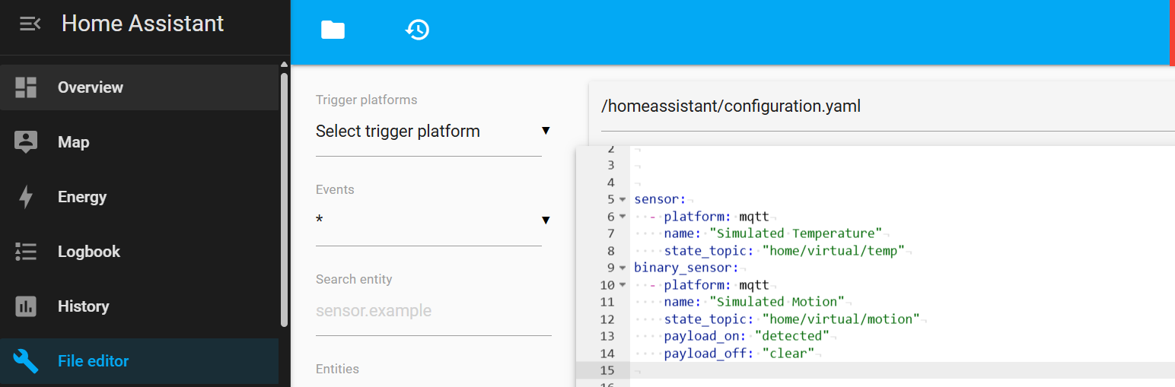
Figure 1: Example sensor configuration

Simulated IoT Traffic Using Python Scripts
Simulated IoT devices are created using a Python script with the paho-mqtt library, executed externally in Visual Studio Code. These scripts publish messages to the MQTT broker to represent sensor data.
Two simulation modes:
- Normal Operation: Devices publish periodic, realistic sensor values.
- DDoS Simulation: Hundreds of virtual devices rapidly publish messages to simulate a flood.

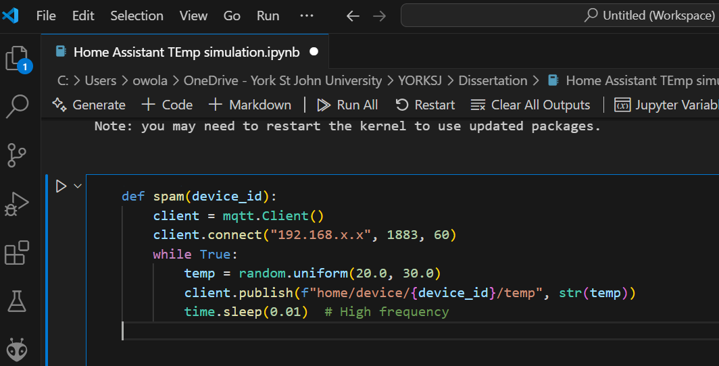
Figure 2: Sample DDoS simulation code

This mimics an application-layer DDoS attack targeting the MQTT broker.
Data Logging and Traffic Collection
MQTT traffic data is collected for analysis using two methods:
- Subscribing to all topics via mosquitto_sub
- Modifying the simulation script to log every publish event to a CSV
The dataset includes:
- Timestamp
- Topic
- Payload
- Device ID
- Message frequency
This forms the training and testing data for AI models.
AI-Based Detection Engine
The anomaly detection model is implemented using Python libraries such as pandas and scikit-learn. An Isolation Forest model is trained on MQTT traffic patterns to detect anomalies indicating a DDoS attack.
Steps in the detection pipeline:
- Load and preprocess traffic logs
- Extract features (e.g., messages per device per second)
- Train the Isolation Forest model
- Predict anomalies in real-time or batch mode
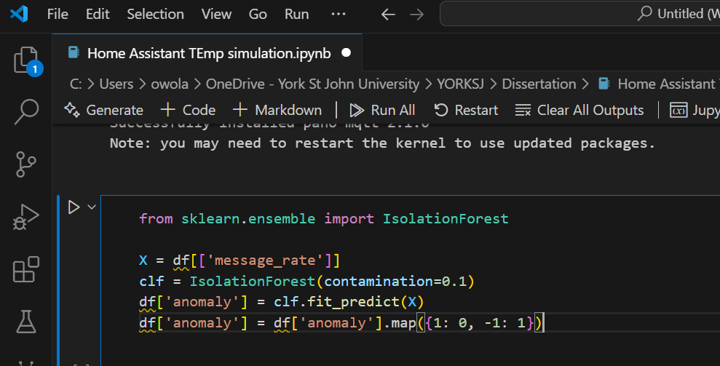
Figure 3: Example code

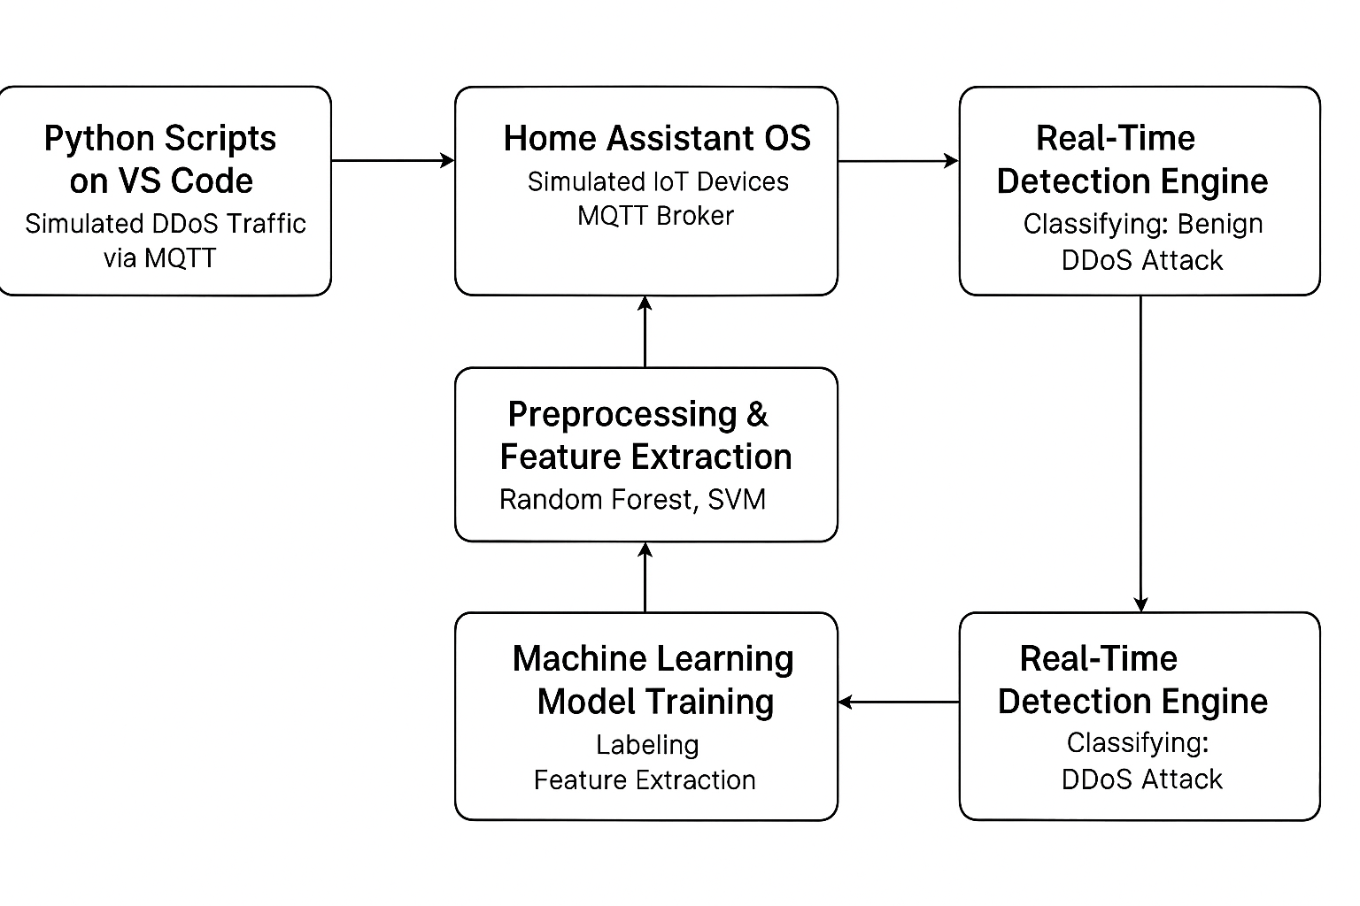
Figure 4: Flowchart Diagram
Tools and Technologies Used
Component | Tool/Platform
Smart Home Platform | Home Assistant OS
Simulation Host | VMware Workstation
MQTT Broker | Mosquitto
Scripting Language | Python + paho-mqtt
IDE/Execution | Visual Studio Code
AI Libraries | pandas, scikit-learn
Logging | MQTT CLI or file logging
This setup allows safe, controlled simulation and analysis of DDoS attacks within a smart home ecosystem, with the objective of developing effective AI-based detection mechanisms.
PROJECT TIMELINE
Month | Task | Description
May-25 | Project Setup | Install Home Assistant, set up MQTT, test sensors
Jun-25 | Traffic Simulation | Simulate normal & DDoS traffic using Python + MQTT
Jul-25 | Data Collection | Collect and label traffic data
Aug-25 | AI Model Development | Train and evaluate AI detection models
Sep-25 | Integration & Testing | Link AI with Home Assistant, test detection
Oct-25 | Results Analysis | Analyze detection output, visualize results
Nov-25 | Writing & Editing | Draft and refine dissertation
Dec-25 | Final Submission | Submit project and prepare presentation

WHAT EXISTING LAB EQUIPMENT DO YOU NEED ACCESS TO UNDERTAKE YOUR PROPOSED PROJECT:

N/A
PLEASE LIST ANY MINOR EQUIPMENT YOU MUST PURCHASE TO COMPLETE YOUR RESEARCH PROJECT: (eg,
switches, resistors, raspberry pi, arduino etc)
N/A
PLEASE LIST ANY MAJOR EQUIPMENT YOU REQUIRE TO COMPLETE YOUR RESEARCH PROJECT ALONG WITH
LINKS TO WHERE IT MAY BE PURCHASED (eg a Drone, mobile phone etc).
N/A
HAVE YOU DISCUSSED THE FEASIBILITY OF YOUR PROJECT WITH A MEMBER OF THE TECHNICAL TEAM? IF SO WHO?
Yes, with ………….

(staff use only) Project Approved by Technical Team? | YES |  | NO
Please comment on the Feasibility of the project:

This RP is approved provisionally subject to the following:
- Student needs to demonstrate that the project plan and milestones are achievable and realistic. Project plan lacks clarity, detailed milestones and activities.
- Student needs to ensure thorough understanding of the project details. Lacking details to many aspects of the project, no description of Home Assistant OS, figures are not explained, no system diagram, no simulation setup.
- Quality of RP is poor, lacking details to many aspects, no clarity to project plan.
- Student has not demonstrated sufficient technical understanding of this project, e.g. how DDoS attack can be prevented/detected.
This project requires further work and student needs to address the issues above.

Section 3: Ethics Approval

This section of the form will help ascertain if you need to complete and undergo the universities research ethics approval process. Please answer all questions honestly.

Question | Yes | No
Does your Research involve any of the following?  Human participants / subjects, Human tissue, Documents |  | No
Will the research require the collection of primary source material that might be considered offensive or illegal to access or hold on a computer? (e.g. studies related to state security, pornography, abuse, illegal behaviour or terrorism). |  | No
Does your research concern group which may be construed as terrorist or extremist? |  | No
Will the research involve visual/vocal methods where participants may be identified? |  | No
Will the research involve the use of genetic data (inherited/acquired genetic characteristics resulting from the analysis of a biological sample)? |  | No
Will the study require the co-operation of a gatekeeper to give access to, or to help recruit, participants? (eg, headteacher or group leaders publicising your work) |  | No
Will it be necessary for participants to take part in the study without their knowledge or consent at the time? |  | No
Will the study involve recruitment of patients through the NHS? |  | No
Will inducements be offered to participants? (eg the offer of being entered into a prize draw) |  | No
Does the study involve participants who are particularly vulnerable or unable to give informed consent? (e.g. participants under 18. Adults with learning disabilities, the frail elderly, or anyone who may be easily coerced due to lack of capacity) |  | No
Is there a possibility that the safety of the researcher may be in question? |  | No
Will the study require participants to commit extensive time to the study? |  | No
Are drugs, placebos or any other substances to be administered to participants, or will the study involve invasive, intrusive or potentially harmful procedures of any kind? |  | No
If there are experimental and control groups, will being in one group disadvantage participants? |  | No
Is an extensive degree of exercise or physical exertion involved? |  | No
Will blood or tissue samples be obtained from participants? |  | No
Could the study induce psychological stress or anxiety or cause harm or negative consequences beyond the risks encountered in normal life? |  | No

This part of Section 3 requires you to thoroughly identify and mitigate the ethical challenges of your research project. This is required to enable the computer Science ethics panel to properly consider if your proposed project requires you to submit a formal proposal to the university ethics panel.

With your answers to the previous questions in mind, please describe the main ethical challenges of your research project and how you propose to mitigate them. Your discussion may include material not covered in the above questions. Please be as thorough as possible: N/A

